**Format for uploading details in Github and Slack in word file format**

**(Fill this format(docx) daily and upload it in both Github and Slack)**

**Student Name : SURYA PRAKASH S**

**Class and Sec : VI B**

**USN : 4AL17CS101**

|  |  |  |  |  |
| --- | --- | --- | --- | --- |
| **Online Test Details** | | | | |
| **Subject** | **-** | | | |
| **Semester** | **VI -B** | | **Duration** | **-** |
| **% of marks** | | **-** | | |

**Encl : snapshot of the test result**

|  |  |  |  |
| --- | --- | --- | --- |
| **Certification Course Details** | | | |
| **Course** | **Introduction to Data Studio** | | |
| **Certificate Provider** | **[Google](https://Google" \o "https://Google)** | **Duration** | **10 hours** |

**Encl : snapshots of the daily class acitivities (atleast two snap shots)**

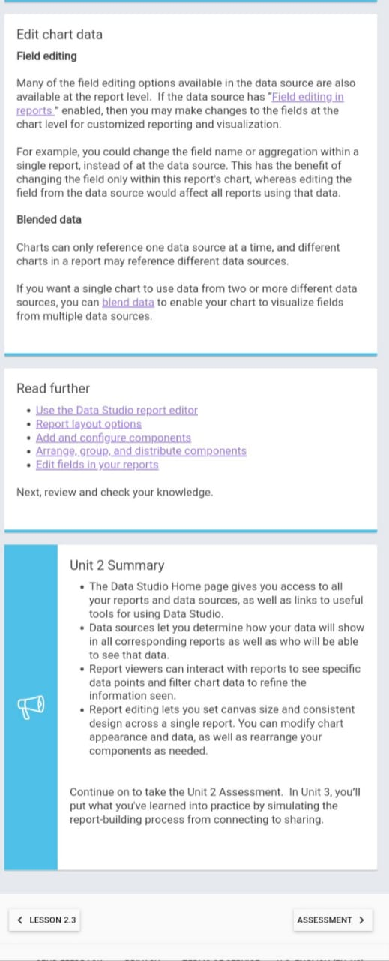

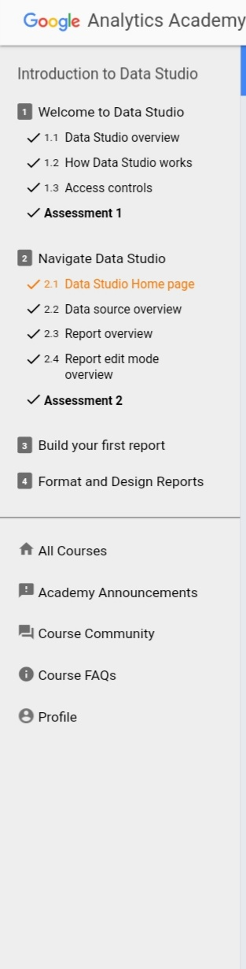

|  |  |
| --- | --- |
| **Coding Challenges** | |
| | **Problem Statement: 1.** Write a C++ program to declare a matrix of size 3*3 matrix of size, initialize the matrix and display them. Also find the sum of matrix elements, sum of main diagonal elements and secondary diagonal elements. 2. Write a C++ program to find the sum of 2 integers using Pointers 3. Write a C++ program to enter the details of students and display them using class and object. The details should be private in nature and use public members function to access the private members 4. Write a C++ program to enter the details of students and display them using class and object. The details should be private in nature and use public members function to access the private members.(Define the member function outside the class). | | --- | | |
| **Status: Completed** | |
| **Uploaded the report both in Github & Slack** | **Yes** |

**Encl : snapshots of your response to challenge.**

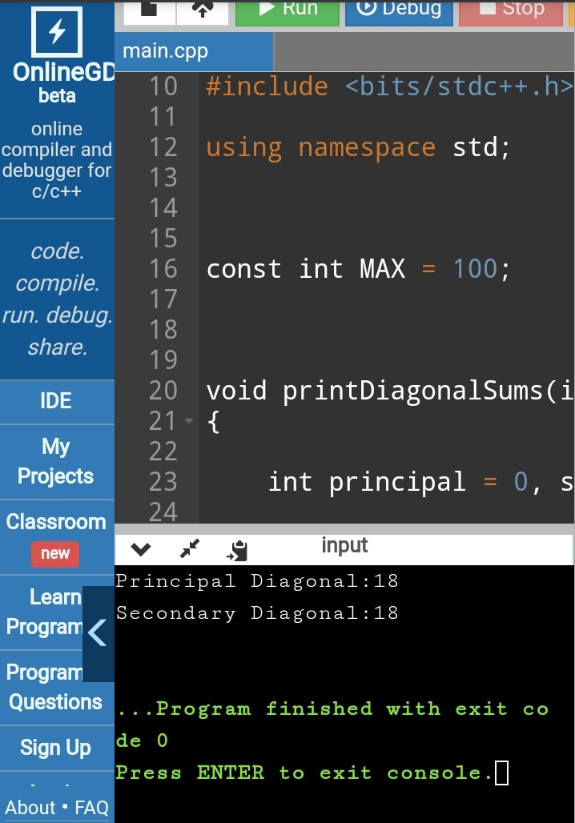

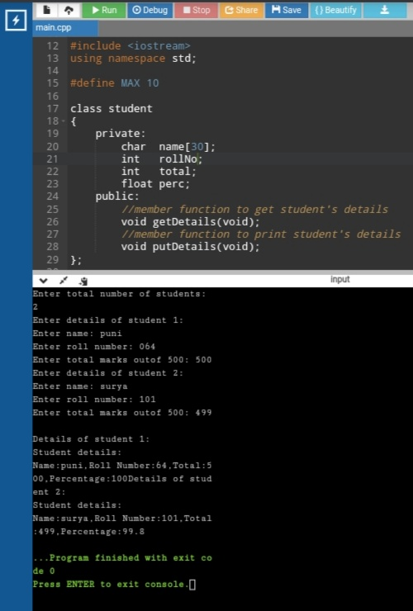

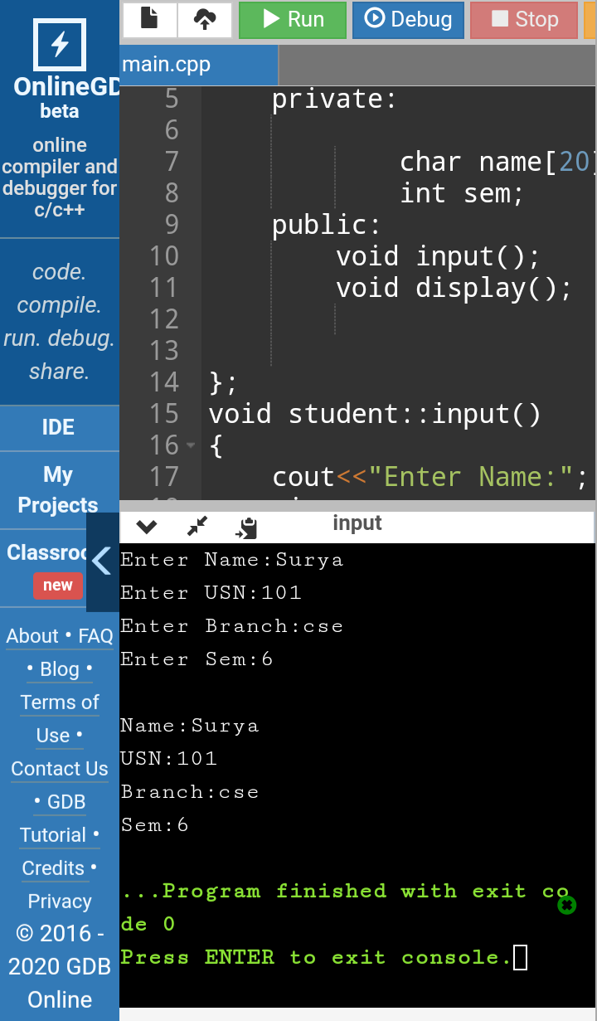

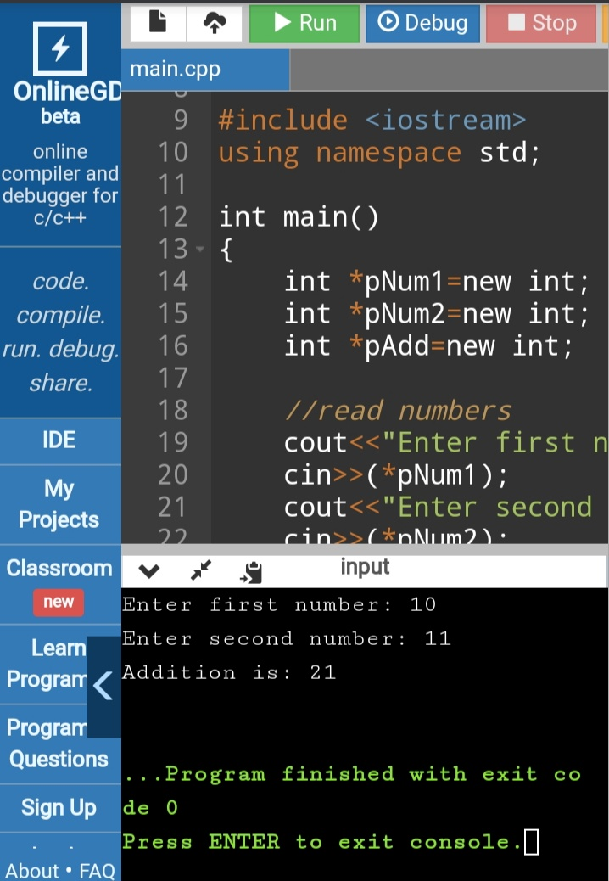

https://github.com/SPSSURYA/Online-Coding-And-Certification-Course